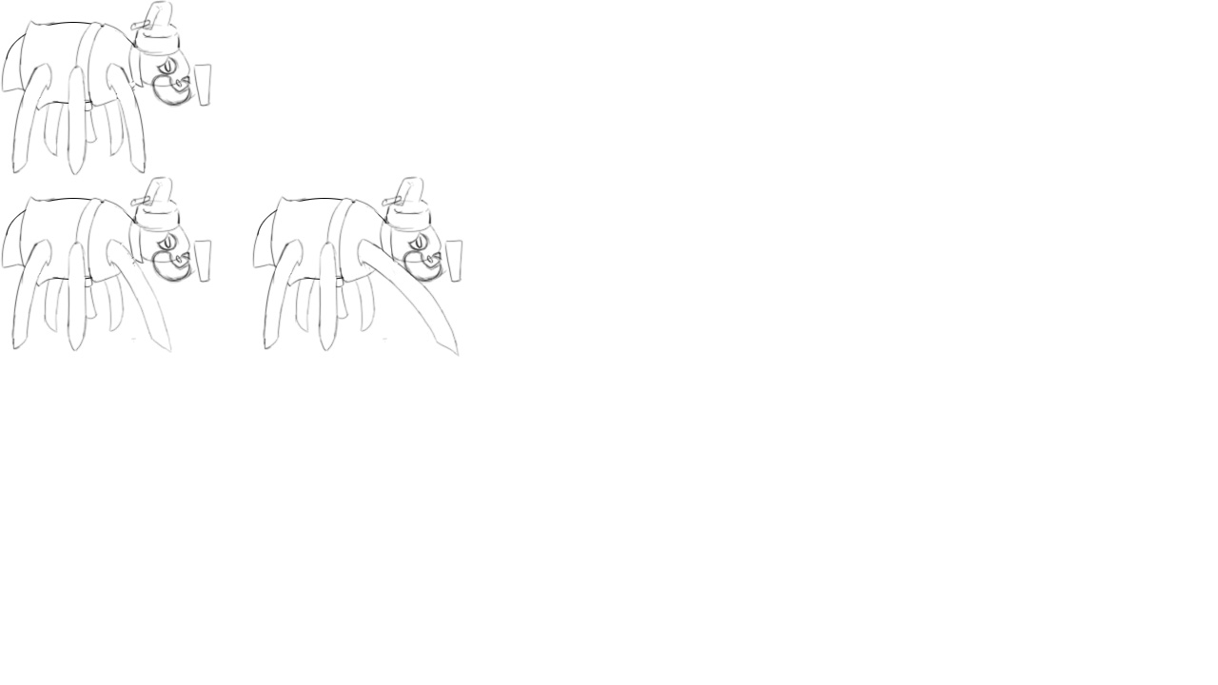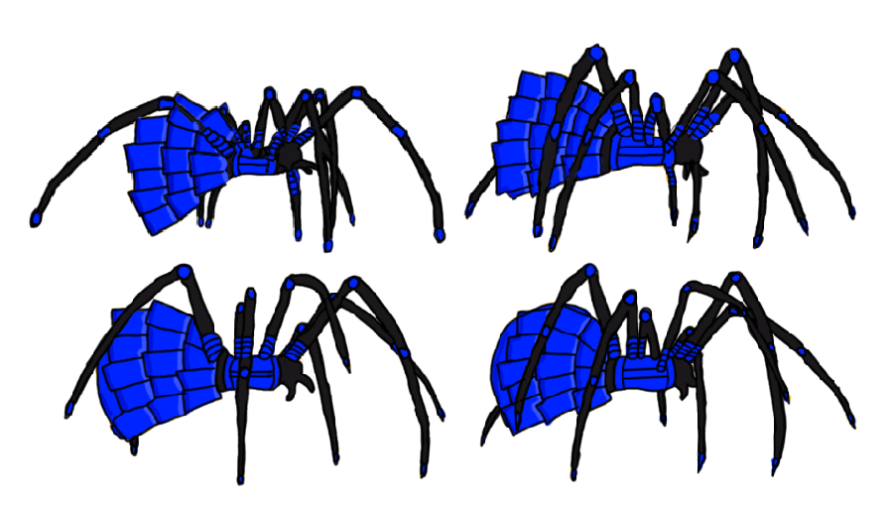
The spider Shogun is the main objective of the game, it is the players primary goal to assassinate the boss that has the protagonists rabbit citizens imprisoned. The main objective to defeating the enemy is by sneaking pass the Shogun without the boss noticing and upon successfully executing this task it will trigger an animation of the playable character taking the Shogun down.

